Evaluation Only. Created with Aspose.Words. Copyright 2003-2022 Aspose Pty Ltd.
VIVEK JOSHI 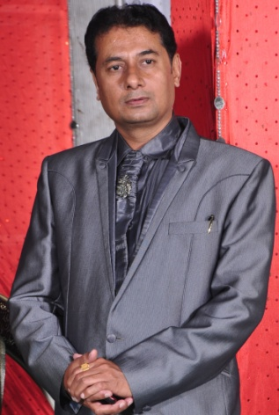
Mobile No. : - +919826044084
Email ID: - vivek16joshi@gmail.com
LinkedIn Profile: - https://www.linkedin.com/in/vivek-joshi-9700105a

OBJECTIVE:-
Always keen to get a challenging job which will offer more opportunities and will help in my profession and self development and would be mutually beneficial to my organization and me.
SKILLS:-
- Highly motivated.
- Good communication skill.
- Determination towards work.
- Can work under stress & popular and effective leader of any team.
- Displaying excellent man management skills with positive input. Having vast experience from site engineering to site management.
Professional rundown:-
- A result oriented leader with more than 25 years of extensive experience in project planning & co-ordination, building and real estate construction, bar bending scheduling, cutting, bending, binding, substation, foundation casting, pilling, road & service building with desirable Quality Assurance etc.
- Presently working in Kalani Group(Treasure Group) as a HEAD Purchase/Project.
- Served to PROJECT of Mirchandani group ISO:-9001 certified company (Shalimar Housing and finance Ltd) as a project manager, high rise residential project.
- Excellent expertise in site Executions/supervision from foundation to finishing level.
- A strategic planner with expertise in planning, executing & spearheading projects involving Site Administration and Resource Planning.

CARRER FEATURES:-
Vast experience mainly in Patel group, Agrawal group, LS Vasvani Architects Pvt Ltd as a civil engineer . About work in
These organizations, clearly mentioned in my Linked in profile.

RESPONSIBILITIES:-

Project Planning & Management
- Evaluating designs; coordinate with consultants and Sub contractors for changes in the same.
- Ensuring the execution of projects within time, cost & budgetary parameters.
- Managing the projects activities right from sight survey to construct high rise building residential or commercial.
- Handling all construction activities including providing technical inputs for construction & coordination with site management activities.
Coordinating with contractors; monitor their performance in view of project schedule. Assist in setting all techno-commercial disputes/clarification during execution of project.
EDUCATION:-
D.C.E in civil engineering in 1990.
Higher secondary in 1985.
TECHNICAL SKILLS:-
- MS-WORD, MS-EXCEL, PowerPoint
PERSONAL DETAILS:-
Father’s Name - Mr. N.R Joshi
Sex - Male
Nationality - Indian
Marital Status - Married
Languages Known - English, Hindi & German
DECLARATION
I hereby declare that all the information furnished by me above is true to the best of my knowledge.
(VIVEK JOSHI)

